**Sintering Fit**

**User manual**

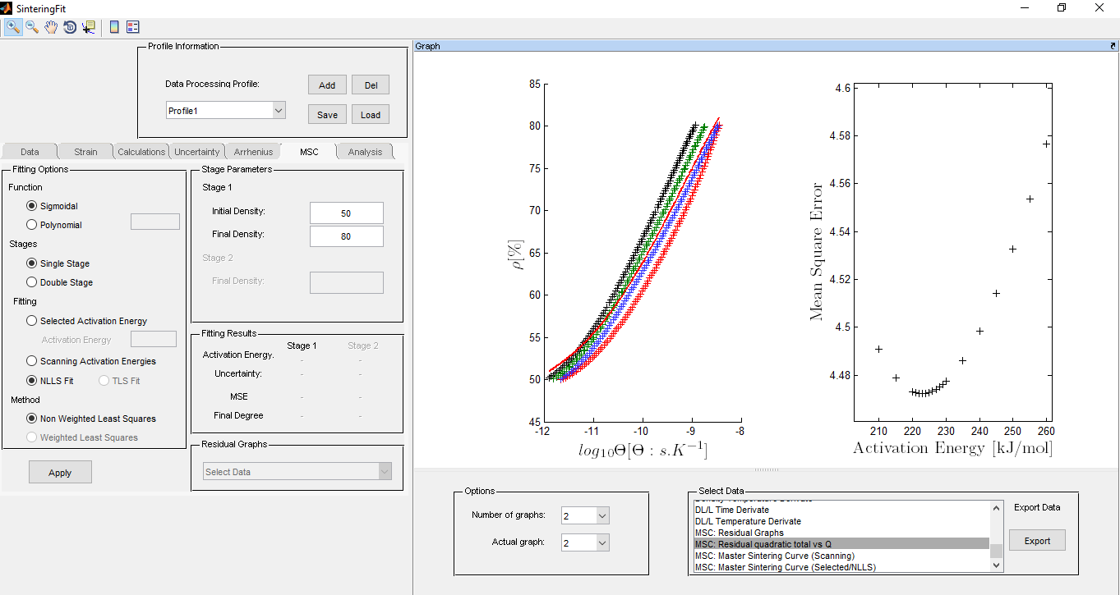

Batista, R.M.; J.F.R. Naranjo; and E.N.S. Muccillo

V1.0 - 2014

November, 2020

**ABOUT**

The purpose of the program is performing sintering analysis from dilatometric data, enabling construction of master sintering curves, Arrhenius curves and density predictions.

The program was developed by Rafael M. Batista, J.F.R. Naranjo, and Eliana Muccillo, in Brazil, 2014.

For future publications, using the software, please make citations to *Mater. Sci. Forum 912, p.240 (2018).*

All rights reserved.

**ATTACHMENTS**

Following the executable archive, you will find Matlab runtime, necessary for running the software, if not installed on your computer.

It has a readme file, that has some commentaries about installation and configuration.

Examples of input archives are sent, as a saved project, to easily the introduction to software.

To visualize all gr

If you have any doubts please contact morgadoph@gmail.com, Rafael Batista.

**I – Project control**

The project control is made on the initial screen of the program. The **Profile information** box has four options:

**Add** – Add new profile (for new analysis)

**Del** – To exclude profiles from project

**Save** – To save projects and open later

**Load** – Load saved projects

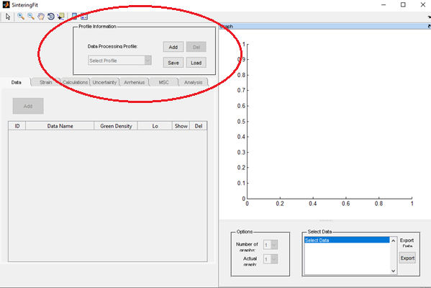

If you click on Add button, on the Profile information Box, then you will get access on Data tab. You can work on different parallel projects and save them to continue working later.

**II – Data tab**

Data tab is used to input data and to control some options of graphs visualization.

Click on **Add** button, on **Data** tab, to select the input archives. The raw data need to be in the ASCII (.dat) format:

**Time (sec) Temperature (oC) Displacement (mm)**

When you add curves the graph options will be enabled, and the data will be presented.

Enter on table the green density and initial length of samples. Just click on spaces and enter the information using keyboard. You will be able to change the curves colors, clicking on the colors buttons. You can select only some curves to visualize data, but notice that data not selected is used on the calculations, only not showed on graphs.

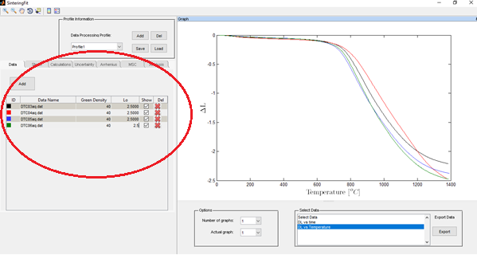

**II – Strain tab**

The strain tab is utilized to get DL/L0 measurements.

You can select corrections, depending on your input data, for reliable results on MSC.

Construction of MSC consider that samples have the same initial properties, as green densities, and initial sample lengths Lo. The theory does not consider the thermal expansion of sample or even instrumental.

The low temperature range densities curves should be the most similar as possible, since sintering mechanisms are not working significantly at this temperature range.

The corrections below are options for users and to verify the stability of MSC results but should be used carefully.

**To correction** – Some devices present irregular measurements on low temperatures. User can cut low temperature data and set initial temperature to a specific temperature. In this case the samples Lo will be changed automatically accordingly to expression:



**Lo correction** – Some samples present different behaviors on low temperature range, like exposed below. The difference on the curves should not be observed and can affect the MSC activation energies results, since the nonlinear fit is extremely sensible to input data. The software enables two option methods for correction the DL/Lo curves:

* *Extrapolation method*: A straight linear adjustment is made on all curves. The initial displacement (intercept) is determined, and the value is added to all data points. The reason of this method is that all displacement curves should begin on zero, for initial temperature.
* *Translation method:* One curve is taken like reference, chosen on the box. The mean displacements of the curves are taken on the selected temperature range. All curves are translated to converge on the reference displacement data. This is an empiric method and, is valid, only for small differences on the curves, since it has no theorical fundamentals



*Not corrected DL/Lo curves*



*Corrected DL/Lo curves*

**Push rod expansion** – Dilatometers push rod thermal expansion need to be corrected to get reliable and precise measurements. The correction is made by the analysis of a standard sample, with calibrated displacement, usually a translucent alumina sample. The commercial equipment has options to get the data curve correction. The correction can be made directly on software if an archive is input on the following format:

**Temperature (oC) DL/Lo correction a (K-1)**

Where a is the thermal expansion coefficient.

**Sample thermal expansion** – Samples thermal expansion can be evaluated from cooling curves of well sintered samples. The thermal expansion can be corrected from all curves entering one only data archive, on the following format:

**Temperature (oC) DL/Lo correction 0**

The third row is used only for development and needs to be zero.

**DLMethod** – This method is enabled when Push rod thermal expansion and sample thermal expansion are selected. The corrections are applied accordingly to *J Therm Anal Calorim (2016) 126:1007–1013*, to get more accuracy results. The principle is that push rod and sample thermal expansion depend of length of sample, but during sintering it changes because of shrinkage. The model is a second order correction that consider the instantaneous length of sample to determine the best thermal expansion correction factor for each temperature.

**III – Calculations tab**

The calculation tab is utilized to determine densities and derivates curves, that will be used for MSC construction or Arrhenius analysis.

**Instantaneous shrinkage** – Calculate DL/L curves. The instantaneous L is calculated accordingly to:



**Densities** – Calculated accordingly to *J Therm Anal Calorim (2016) 126:1007–1013*. There are few options to densities calculations.

*Uncertainty box*: Enter the estimated uncertainty on green densities samples. The data is utilized to calculate the covariance matrix of density data, to be used as option on nonlinear weighted least square fit.

*Density data*: This option enable to input an archive of conventional sintering data, to be showed on graph, together to dilatometric densities curves. The option is utilized to compare densities results from dilatometry and conventional sintering. The MSC constructed only will be reliable if the densities curve has enough accuracy. The density data archive needs to be on the following ASCII (.dat) format:

**Temperature (oC) Density (%)**

*Mass lost correction*: This option is extremely important for samples made by nanopowders, since they usually have significantly mass lost on low temperature range. You can load a single mass lost archive data or multiple mass lost archives data, being one for each heating rate. The archive needs to be on the following format:

**Temperature (oC) M/M0 0**

The second row is the absolute value M/Mo, where M is the instantaneous mass and Mo the initial mass. The factor can be easily evaluated by thermogravimetric analysis.

The third row is used only for development and need to be zero.

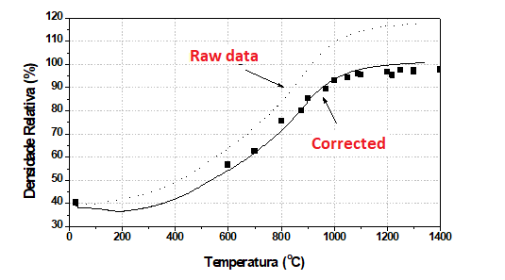

*Densities curves obtained for GDC nanopowders from raw data (without mass loss correction) and correcting mass loss. The data points are densities from conventional sintering samples.*

**Densification** – Calculated accordingly to following definition



**Smoothing** – Derivates curves can be smoothed by moving average filter. This process is important on Arrhenius analysis, where derivatives curves are utilized. To enable option just to go to graph options display and select the derivatives graph on the box. Use the respective options of the filter commands.

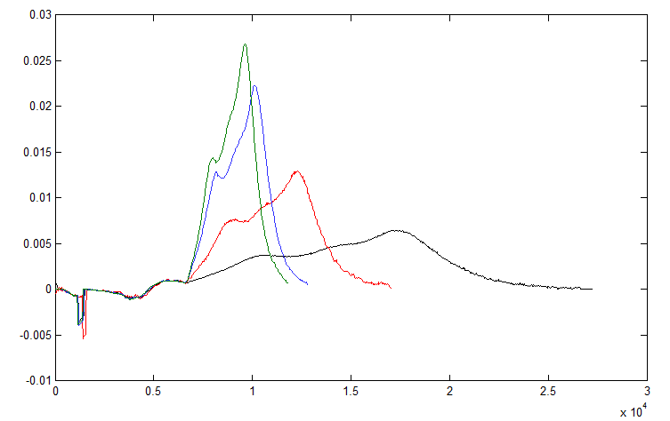

*Corrected derivative curve*

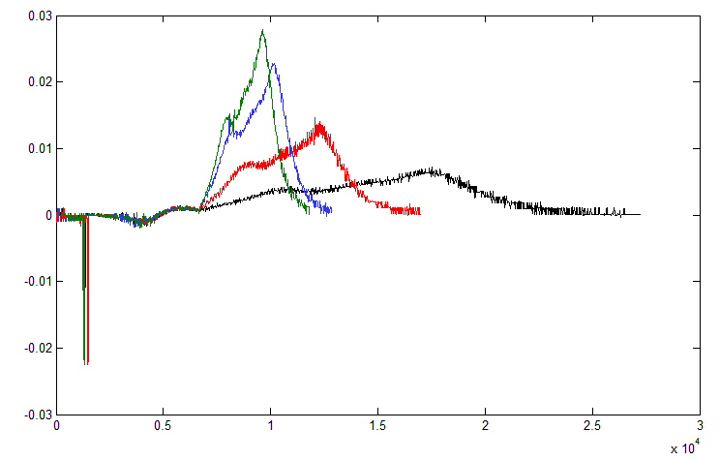

*Not corrected derivative curve*

**IV - Uncertainty Tab**

The uncertainty tab is utilized when MSC is constructed by weighted least square.

The covariance matrix needs two inputs, the resolution of the device and the green density uncertainty (entered on Calculation tab).

A more complete calculation of the covariance matrix involves modification of uncertainties function of the dilatometer, but it needs specific modifications on program code.

After click on apply the results will be storage on project memory.

**V – Arrehnius tab**

Arrhenius tab is utilized to perform sintering analysis accordingly to Wang, J e Raj, R.; *Estimate of activation energies for boundary diffusion from rate-controlled sintering of pure alumina, and alumina doped with zirconia or titania*. **J. Am. Ceram. Soc.**, v. 73, p. 1172, 1990.

The program uses the densities curves, calculated previously, and derivatives data, after smoothing process. The program plot linear fits accordingly to following expression, to different densities values. The data is selected from curves of different heating rates curves.

**Density data**



**Strain data**



The input information is initial density utilized on analyses, final density, and density step to select data.

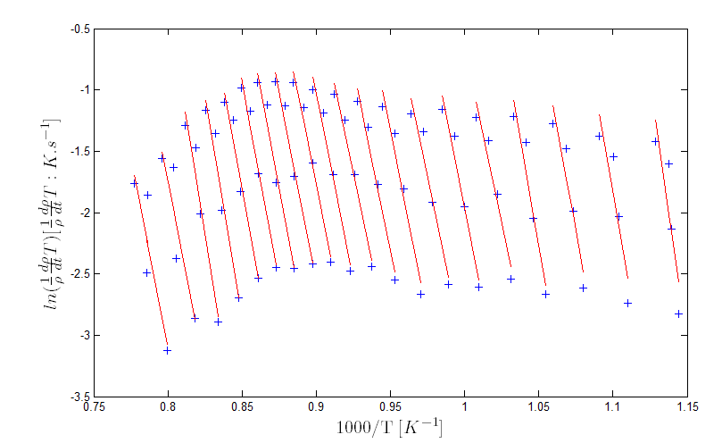

*Example of graph obtained on Arrhenius analysis.*

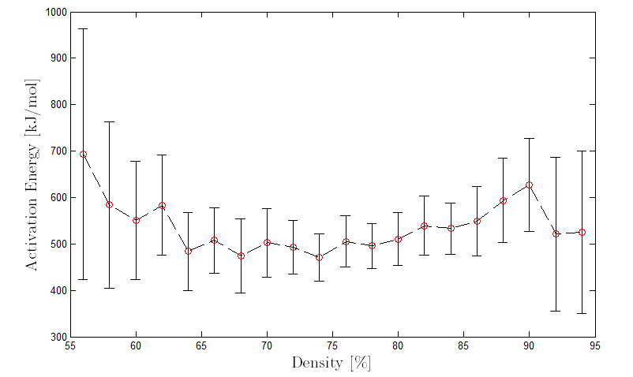

*Activation energies as function of density utilized for linear plots.*

**VI – MSC tab**

MSC tab is utilized to construct MSC curve from density data calculated, accordingly to Su, H.; Johnson, D. L.; *Master sintering curve: A practical approach to sintering*. **J. Am. Ceram. Soc*.***, v. 79, p. 3211, 1996.

The software has three options for MSC construction:

*Selected activation energy:* The MSC curve is fitted with a fixed activation energy, entered as an argument. It is an option that permits to visualize the changes of MSC quality for different activation energies.

*Scanning activation energy:* The program performs multiples MSC fittings using activation energies between 150 and 5000 kJ/mol. It determines activation energy that results on the minimum MSE (mean squared error) and then make another scanning around this value, to precisely determine the best activation energy. The result can be utilized later to nonlinear fit, as initial parameter, where sintering activation energy is utilized so as argument on fitting process.

*NLLS Fit:* Nonlinear fit that utilize the activation energy as an argument of fitting algorithm. The nonlinear fit is extremely sensitive to initial inputs, so it is enabled only after running the scanning mode first. The non-weighted and weighted least square can be utilized if the uncertainties were computed before.

To perform MSC fit the user needs to select the density interval range. Density is utilized as input data for construction, but usually low densities range and final stage sintering are not considered. The software gives the option for the user.

The MSC curves can be constructed using two kinds of functions, described below.

*Sigmoidal*: it is the more frequently function used for MSC construction. The sigmoidal expression has advantages, when compared to polynomial, mainly to extrapolation of MSC to higher Q(t,T) values, to be utilized with long sintering temperature-time profiles.

*Polynomial:* Initial function proposed to MSC construction, polynomial of 1 to 7th order can be utilized. To determine the correct polynomial order the MSE data can be utilized to perform statistics tests.

The results are showed on the results box.

The traditional MSE x activation energy is showed on entire fitted range. To get the traditional presented curve the user will need to do a zoom near to best activation energy fitted.

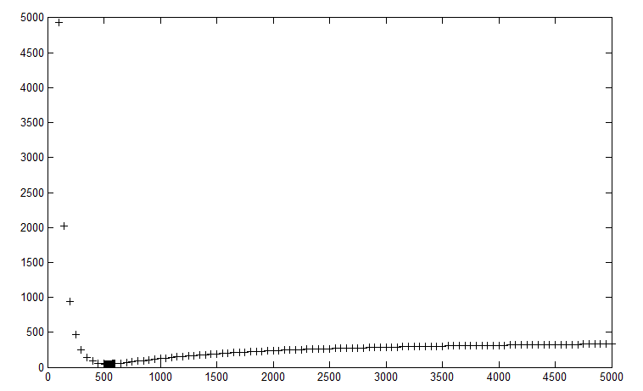

*MSE vs activation energy for entire range*

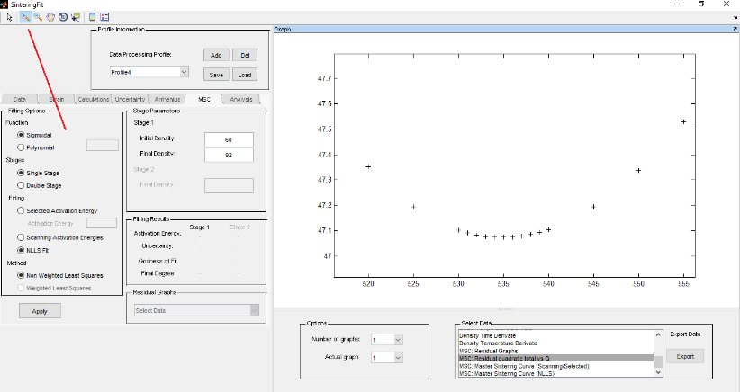

*MSE vs activation energy near minimum value. Notice the parabolic behavior, as expected. The zoom tool is on the top, indicated by red line.*

There is an option on the graphs that are residual graphs. It enables a box to choose the activation energy to analyze the residuals of all curves to MSC curve fitted. It is used for trend analysis.

**VII – Analysis tab**

The analysis tab is utilized to predict sintering densities of arbitrary time-temperature sintering profiles. It can be calculated to a specific time-temperature profile or determined by sintering map.

To predict the densities for a specific time temperature profile the user just needs to enter heating rate, dwell time and dwell temperature of the conventional sintering. The software permits the prediction of density for one or two step sintering profiles.

The sintering map can be constructed for one stage sintering. Two stage sintering map are not available at this moment. The legend box shows the colors for the curves, where the values are dwell time, in hour.

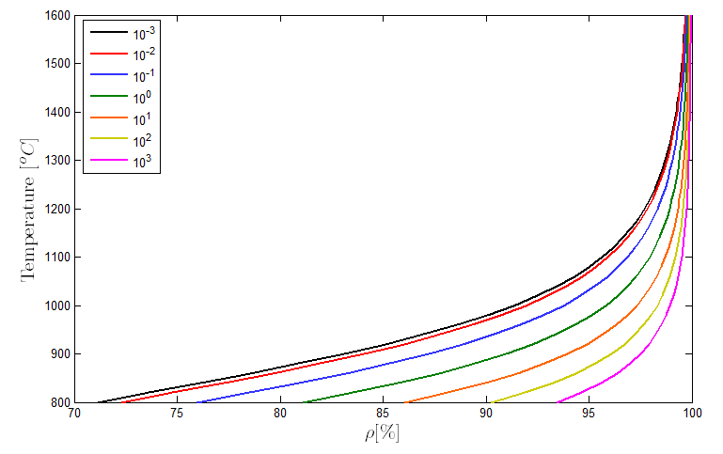

*Sintering map example. The legend indicates the dwell time, in hour.*

**VII – Graph control and data export**

Graph control permits that user visualize one, two or four graphs at same time. The controls stay on **option** box. Each time that software makes calculations it increases the options on **select data** box.

To export data user needs to select the data on box and then click on **export**. An ASCII (.dat archive will be exported to be able to manipulate data on other software.